**ASSIGNMENT 3**

1)

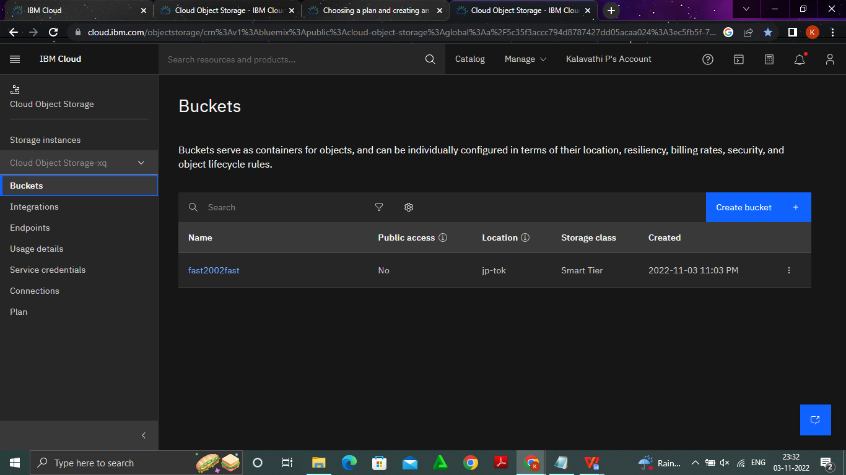

**2)**

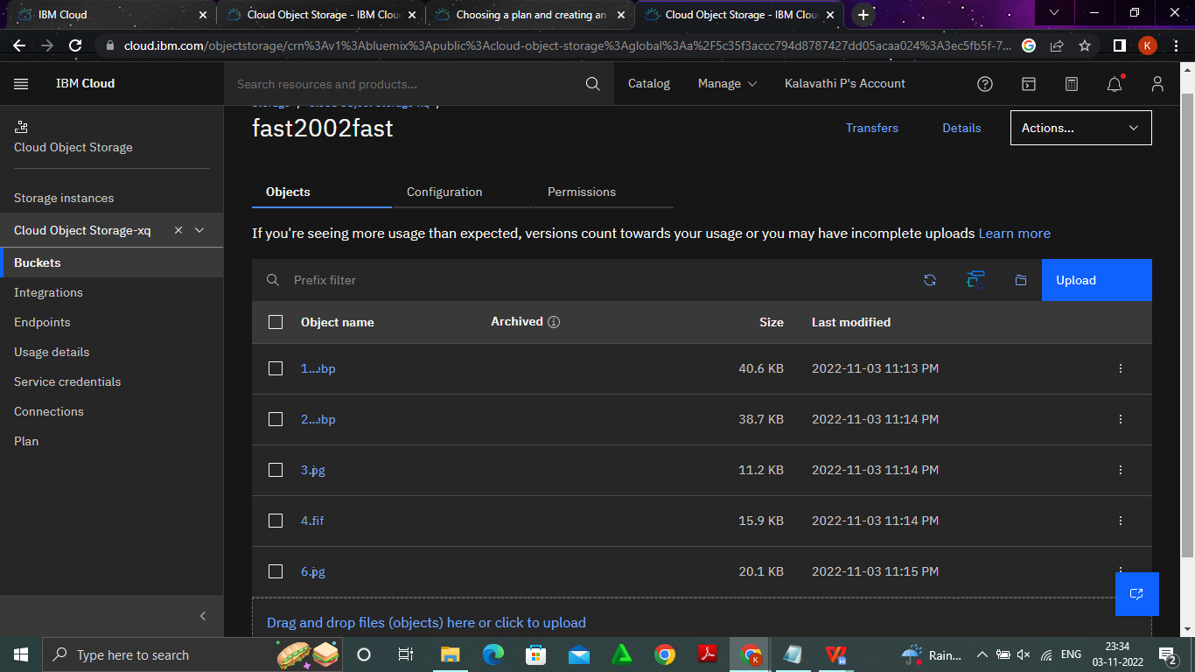

<!DOCTYPE html>

<html lang="en">

<head>

<meta charset="UTF-8">

<meta http-equiv="X-UA-Compatible" content="IE=edge">

<meta name="viewport" content="width=device-width, initial-scale=1.0">

<title>Document</title>

<link rel="stylesheet" href="https://sbka21.s3.us-east.cloud-object

storage.appdomain.cloud/style.css">

</head>

<body>

<img src="https://sbka21.s3.us-east.cloud-object

storage.appdomain.cloud/img1.jpg" alt="">

<img src="https://sbka21.s3.us-east.cloud-object

storage.appdomain.cloud/img2.jpg" alt="">

<img src="https://sbka21.s3.us-east.cloud-object

storage.appdomain.cloud/img3.jpg" alt="">

<img src="https://sbka21.s3.us-east.cloud-object

storage.appdomain.cloud/img5.jpg" alt="">

<img src="https://sbka21.s3.us-east.cloud-object

storage.appdomain.cloud/img4.jpg" alt="">

</body>

</html>

**3)**

img{

text-align: center;

height:250px;

width:250px;

}

<!DOCTYPE html>

<html lang="en">

<head>

<meta charset="UTF-8">

<meta http-equiv="X-UA-Compatible" content="IE=edge">

<meta name="viewport" content="width=device-width, initial

scale=1.0">

<title>Document</title>

<link rel="stylesheet" href="https://sbka21.s3.us-east.cloud-object

storage.appdomain.cloud/style.css">

</head>

<body>

<img src="https://sbka21.s3.us-east.cloud-object

storage.appdomain.cloud/img1.jpg" alt="">

<img src="https://sbka21.s3.us-east.cloud-object

storage.appdomain.cloud/img2.jpg" alt="">

<img src="https://sbka21.s3.us-east.cloud-object

storage.appdomain.cloud/img3.jpg" alt="">

<img src="https://sbka21.s3.us-east.cloud-object

storage.appdomain.cloud/img5.jpg" alt="">

<img src="https://sbka21.s3.us-east.cloud-object

storage.appdomain.cloud/img4.jpg" alt="">

</body>

</html>